**File Permission Task**

Create a file with .txt extension

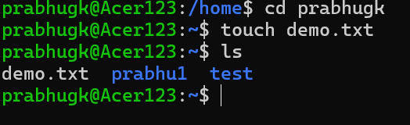

Change the permission set of that file, so that any user can read it, group can read/write & owner can read/write/execute it.

Before filer permission change:

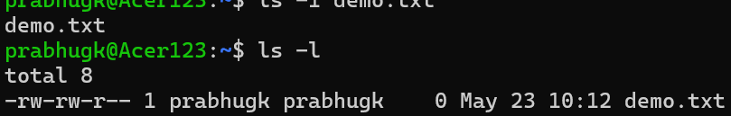

After file permission update.

